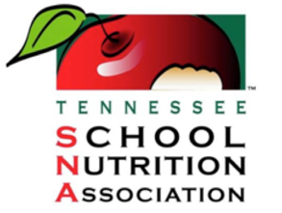

The Helen B. Smith Award

The Tennessee School Nutrition Association is sponsoring the “Helen B. Smith Spirit Award”. The criteria for this award are different from the “Employee of the Year Award”. The employee must be a member of TSNA. This is a state only award. The employee does not have to be a member of SNA or certified by SNA.

This award is to recognize a non-management employee. A single unit School Nutrition Program staff member, who is a TSNA member (excluding managers) may be nominated to win this award. Assistant managers can be nominated. A single unit TSNA member is one who is assigned to one school cafeteria or to a kitchen that serves more than one school.

Nominations must be originated and submitted by another employee. The person that nominates can hold any position in that school (cafeteria employee, teacher, principal, etc.). Only one person per school may be nominated.

The “Helen B. Smith Spirit Award” winner will be recognized at the TSNA state conference. The winner will receive a plaque and a $100.00 cash reward.

All entries must be post marked by April 15, 2024.

Send entries to:

Jennifer Buchanan
Hamblen County Schools
210 E. Morris Blvd
Morristown, TN 37813
buchananj1@hcboe.net

Submission is limited to nomination form, one page maximum to answer question II and three letters of recommendation.

Reminder: Nominations must originate and be submitted by a school employee.

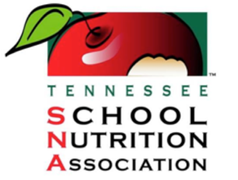

TENNESSEE SCHOOL NUTRITION ASSOCIATION
“Helen B. Smith Spirit Award”
Nomination Form

I.
- Employee’s Name________________________________________________________

- Employee’s School Nutrition Position_________________________________________

- Is this employee a current member of TSNA? __________________________________

- School Name____________________________________________________________

- School System___________________________________________________________

- School Cafeteria Manager__________________________________________________

- School Principal__________________________________________________________

- School Nutrition Supervisor/Director__________________________________________

- Name and position of the person nominating this employee

_______________________________________________________________________

II.
- Describe why you think this person deserves the TSNA “Helen B. Smith Spirit Award.” Include what this person’s contributions have done to improve the school nutrition program and/or the school where he/she is employed. List examples of what this employee accomplished and how he/she goes the “extra mile”. (Answer below or on a separate sheet – one page maximum.)

